# Determine the resistance of Galvanometer by Kalvin method



**Submitted to**

**HASEEN ULLAH JAN**

**NAME MUHAMMAD SADEEQ**

**ROLL NO 75025**

**REG NO 21PWCSE2028**

**SECTION C**

**Department of Computer System Engineering**

**University of Engineering and Technology Peshawar**

**Pakistan**

**Feb 2022**

**Kelvin Method:**

Kelvin Method, after William Thomson, Lord kelvin, who invented the kelvin bridge in 1861 is used to measure very low resistances using four-terminal sensing.

**Apparatus:**

* Post office Box
* High resistance box
* Galvanometer
* Connecting wires
* Battery

# Formula used

G = QR/P

here,

P= AB arm resistance of post office box

Q=BC arm resistance of post office box

R= AD arm resistance of post office box

**DIAGRAM:**

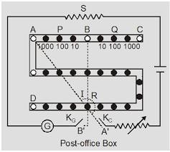

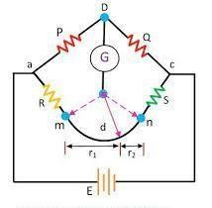

# Procedure

1.Make connections as shown in circuit diagram

1. Mark points A,B,C,D,k1,k2 on the post office box
2. Connect the Galvanometer between C and D and the battery C and k1. Connect D through key2.
3. Take out the plugs from P and Q simultaneously.

5. Press the key k1 and adjust the value of resistance in the high resistance box to obtain the deflection within scale.

6.Now take out the plug from R, press k1 and note the deflection. Also press k2 and note the deflection again. If the needle of galvanometer deflects, go on repeating with the values of R in increasing order.

1. Start with the lower value of R and increase it in steps till on pressing k1 first and then k2 it does not effect.

Repeat the procedure for taking different readings.

**CALCULATIONS:**

The galvanometer always shows some deflection when the key k1 is pressed.  When a balanced point is obtained there is no change of deflection on pressing k2. The resistance of galvanometer remains constant.

|  |  |  |  |  |
| --- | --- | --- | --- | --- |
| S  NO | P  Ω | Q  Ω | R  Ω | G =  QR/P |
| 1. | 10 | 10 | 140 | 140 |
| 2. | 100 | 10 | 1440 | 144 |
| 3. | 1000 | 100 | 1400 | 140 |
| 4. | 1010 | 110 | 1350 | 145 |